MacGraw Hideaway
A 1st-Level Quest for Draw Steel
by Look Out Behind You Studios

“MacGraw Hideaway” is an independent product published under the DRAW STEEL Creator License and is not affiliated with MCDM Productions, LLC. DRAW STEEL © 2024 MCDM Productions, LLC.
MacGraw Hideaway © 2025 Look Out Behind You Studios LLC

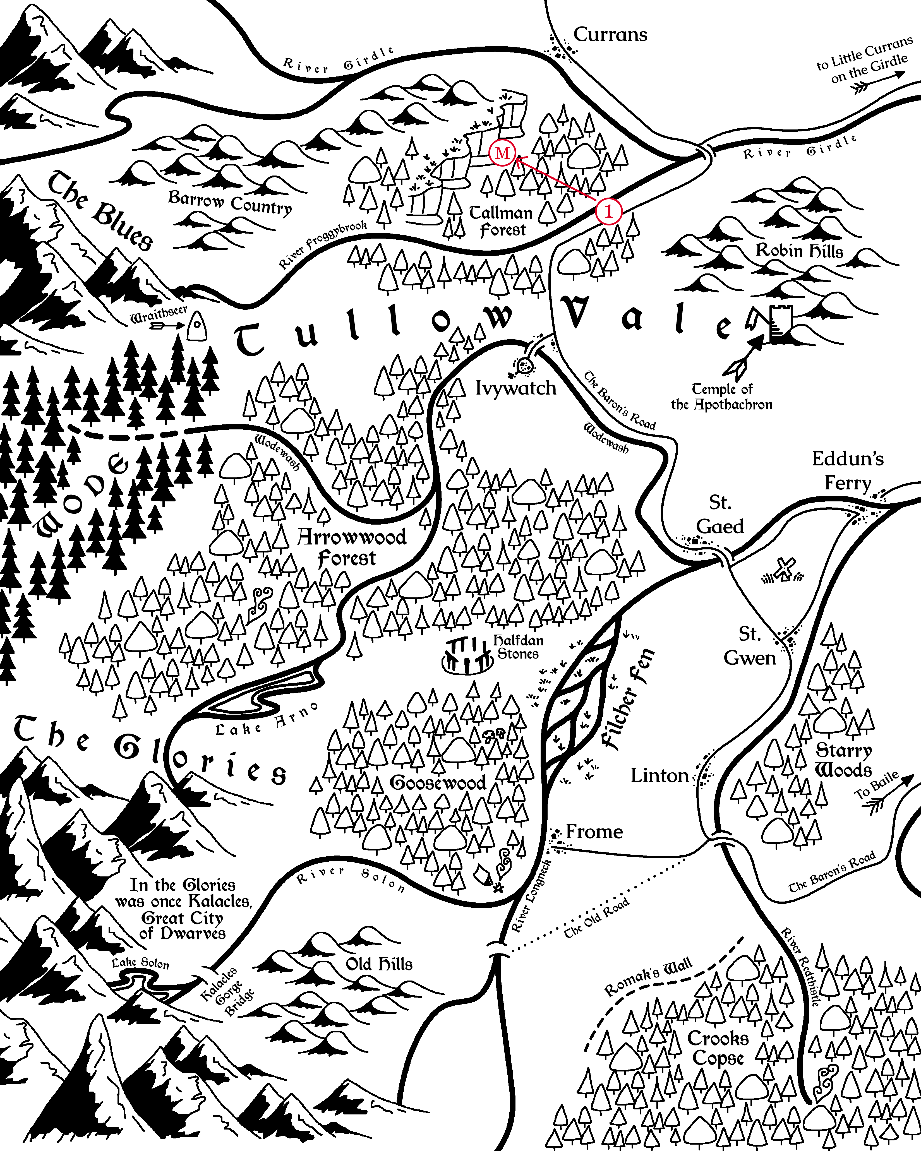
Marked in red are the scenes of MacGraw Hideaway (1: Scene 1, M: Scenes 2 & 3).

MacGraw Hideaway
MacGraw Hideaway is a quest (a short, not-full-level-length adventure) set in Vasloria, a woody, humid, and vaguely Europe-like region of Orden. The quest is designed for two to seven 1st-level heroes and grants up to 6 Victories.

MacGraw Boss, Blarg
The bugbear Blarg has been exiled from his home in Tullow Wode. He seeks to gain power in the way that humans do: wealth and politicks. The goblins he commands are convenient for now, but given another week, he would kill them all himself and take his earnings to the nearest city.
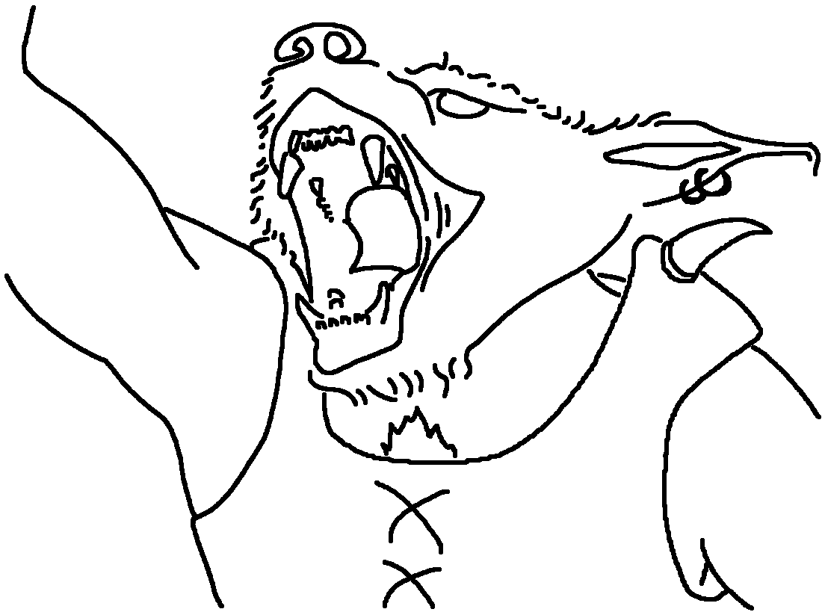

Quest Hook
MacGraw Hideaway assumes the following hook.
Trademark Violation: The last few weeks, goblins have been attacking merchants along the Baron’s Road in Tallman Forest and kidnapping victims. The Company of Cordwainers have been hit the hardest by the attacks, but were content to let the local authorities handle it in their own time, until the goblins gained the moniker of the “MacGraw Tribe.” Tybald MacGraw, the guildmaster of the company, doesn’t like sharing, least of all his name.
The company sends a contact to the heroes in Currans with a job: eradicate the creatures from their hole.

Guide to Tullow Vale
Tullow Vale is tucked in between the foothills of the Myr Mountains of Vasloria, with farmland to the east and elf-haunted wode to the west.

The Central Tension
Long ago, an ancient civilization in Tullow Vale was ruled centrally by a single dwarven king in the great city of Kalacles. In the wake of Ajax’s campaign and the death of the more recent, local Vaslorian duke, the lords of Tullow Vale now question whether to retain the town-and-lord system, paying taxes to but not protected by a distant and apathetic baron, or to centralize power under the Old Ways and choose a new King of the Vale.
Nearby Faction Leaders
Here are some faction leaders that are nearby, but do not appear in this quest.
Tybald MacGraw, Guildmaster of the Company of Cordwainers
“The company knows every boot in the Vale. Where it’s been and where it’s going.”
Guildmaster MacGraw foresees the greatest profit in the Capital of a centralized Vale.

Penwyn Craddock, Lord of Currans
“First godsdamned week of harvest and half the carters are missing or dead! Makes us look like a hamlet!”
Lord Craddock has an economic plan to make Currans a regional market city and doesn’t want to compete with some other Capital.

Scenes
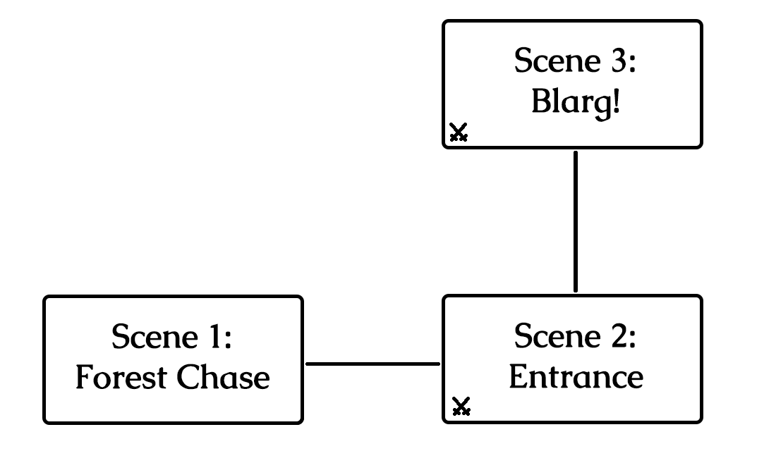
The scenes and how they connect in the quest.

Scene 1: Forest Chase
The contact in Currans told you scant details, but ultimately the job was very simple: eradicate the goblins terrorizing Tallman Forest from their hole and save the company’s journeyman, Silvester Fallwinter, if he lives.
And so you set out and here you are, on the Baron’s Road heading south from Currans.
Boxed, italicized text like this is meant to be read aloud to your players!
Dir. Note: Director notes like this contain information the players should not be told!
Take a moment to do the following:
- Encourage the players to introduce their heroes if they haven’t already.
- Each of the heroes are each well-known in some region, if not this one. Ask each player what the title is of the most popular bard’s song about their hero’s exploits.
- Ask the players how their heroes each spend evenings in camp while on the road and which of their senses they most rely on while searching for goblins.
Every tree in Tallman Forest seems to hide an extra shadow. Every bird’s song sounds a little suspicious.
Suddenly, a scream from a bit further down the road interrupts your focus, and then hones it.
You were just a step to late! As you round the corner, you see the last goblin hit a victim over the head and haul their unconscious body into the forest away from their burning caravan.
Goblins are well known for their ambushes. No normal person would willingly follow a tribe through their home turf.

Following the goblin tribe through their forest is a recipe for disaster without taking extreme care. But if the party takes too much care, they won’t be quick enough to follow!
The heroes attempt a Medium Intuition Group Test to keep an eye out for goblin tricks and traps.
- Fewer than half succeed: The heroes are unable to detect and dodge every trap laid. The heroes begin their next combat encounter bleeding (save ends).
- Half or more succeed: The heroes are capable, through experience or instinct, to detect and evade every single goblin trap, whether hidden or obvious.
The heroes attempt a Hard Agility Group Test to follow the goblin tribe without them knowing, ideally coming upon their hideout without raising any alarms.
- Fewer than half succeed: The heroes falls for every goblin trick in the book, stumbling into pit traps, spikes, and falling bees nests, and the goblins notice! When the heroes arrive at the camp, the goblins are on guard and will not be surprised when the heroes initiate combat.
- Half or more succeed: The heroes deftly follow the goblins from just out of sight, without making a sound. They arrive at the goblin camp completely hidden and with the element of surprise!
The heroes earn 1 Victory if they succeed both group tests.

Scene 2: Entrance
The MacGraw goblins guard their encampment lazily, lounging by the campfire or staring off into the distance. Two of them prod a captured merchant, tied up in a cage. The merchant screams and the goblins laugh.
No one is aware that you’ve arrived. For now, the captive merchant is completely without hope, but in the meantime, you have the element of surprise!

The heroes each begin in any tree on the lowest height. The positions of all enemies are immediately detectable.
The heroes are hidden. They take turns as if in combat, but as long as each turn ends with all heroes hidden, combat will not begin and enemies will not take turns.
Once the enemies are aware of the heroes, combat begins with the enemies surprised! Draw steel!

Draw Steel! “Entrance”
The MacGraw goblins retreat into their cave and try to kill the hostages on the way.
Earn 1 Victory for preventing any goblin non-minion from reaching the box marked “ESCAPE.”
Earn 1 Victory for freeing all hostages while they live.
- Each ledge and wooden platform is 2 squares tall.
- Standing trees are 2 squares tall and provide cover and concealment.

Dir. Note: Secret Tunnel
If the heroes enter the worg pen at any point, they automatically spot a size 1T crack in the wall between some boulders. The crack leads to an 8 square tall shaft, which leads further into the cave. A size 1T hero can fit through the crack, or the crack can be busted wide open by destroyed or otherwise removing 1 square of stone.
If the heroes take the secret tunnel, continue to Scene 3 and skip ahead to the “Rock Throwing Contest.” The heroes begin in the box marked “SECRET.”
Party Size | Malice – Goblins  Enemy Forces:
2+ | Squad A: 6 Spinecleavers (m)  Squad B: 2 Worgs  Squad C: 2 Spinecleavers (m)  Non-Minion A: 1 Cursespitter  Non-Minion B: 1 Cursespitter
3+ | Squad D: 6 Snipers  Squad E: 4 Snipers
4+ | Non-Minion C: 2 Warriors
5+ | More Non-Minions: 2 Warriors per extra hero beyond party size 4

Handling Hostages
- Each hostage has 8 Stamina unless otherwise noted.
- Hostages do not take turns.
- A hero (or retainer) can free all hostages adjacent to them by using a single maneuver.
- Freed hostages deftly and immediately escape the combat, leaving the encounter.
- Using the Grab maneuver on a hostage automatically gets a tier 3 outcome on the power roll. Enemies can grab hostages despite any size difference.
- If a hostage is grabbed by an enemy, freeing them from the grab frees the hostage.

Dir. Note: Tactics

The first goblin minion to take a turn will unleash a shrill whistle. The worgs will move 15 squares (2x move action + maneuver) to get to the minion.

Minions: Harass the heroes while the non-minions escape. Let the minions ride the worgs. If a non-minion were to ride a worg, they would escape too easily.

Use the Swamp Stink malice feature as soon as you can!

Non-minions: First, move as fast as possible to a hostage. Grab the hostage and then begin moving as fast as possible to the box marked “ESCAPE.”

Following the Stream
If the heroes follow the stream further into the cave, continue to Scene 3.

Scene 3: Blarg!
A human scream is drowned out by the dull roar of a waterfall echoing off the slimy walls as the tunnel opens into a large cavern. Tall ledges hide what lays beyond, further inside. Torchlight from around the corner threatens to expose any foolish enough to trespass into the goblin’s den.

The heroes begin hidden and in the box marked “START.” The positions of enemies in “FOG AREA 1” are immediately detectable, but “FOG AREA 2” remains hidden. Heroes take turns as if in combat, but as long as each turn ends with all heroes hidden, combat will not begin and enemies will not take turns.
Once the enemies are aware of the heroes, go to “Blarg’s Introduction.”
- Each ledge and wooden platform is 2 squares tall.
- Silvester has 21 Stamina.

The Lonely Worg
Nearby in its blood-spattered pen is Meatmunch, one of the goblins’ worgs.
Heroes who enter the pen must succeed on a Medium Intuition or Presence Group Test to placate the worg:
- Fewer than half succeed: The worg is upset! It alerts the nearby sniper and the rest of the cavern!
- Half or more succeed: The worg likes the heroes! It stays quiet and doesn’t want to fight against the heroes.
Dir. Note: On success, the worg won’t participate in the combat encounter, if the heroes draw steel. Unless they antagonize it somehow, of course.

Rock Throwing Contest
When the first hero reaches a position at least 4 squares higher than the stream’s outlet, read the following:
The sound of rock hitting metal punctuates the echoes in the cavern. You spy the source: a vile rock throwing contest. A beefy goblin steps up on a boulder and tosses a stone at a pair of cages, each holding one of the kidnapped merchants. The goblin pegs the hostage in the head and they collapse. They won’t be able to take many more.

After reading the Rock Throwing Contest passage, reveal the rest of the cavern (“FOG AREA 2”) and the positions of all the enemies.
While combat has not yet started, after each turn the heroes take, another goblin throws a rock at the hostages. Roll 1d3:
1 | The rock misses and the goblins laugh.
2 | The left hostage takes 2 damage.
3 | The right hostage takes 2 damage.

Blarg’s Introduction
A nasally, sonorous voice shouts in Khelt:
“WHO DARES TO DEFY BLARG?”
A hulking bugbear dressed in mismatched flamboyant silks walks to the edge of the highest ledge, back-lit by a fire pit. He holds a bound human man: Silvester Fallwinter. He continues in stilted and broken Caelian:
“PARLAY WITH BLARG! OR MAN GO SWIM!”
Blarg gestures to the pool beneath him. The captive man yells out.
“Don’t trust it! Forget me and save the others! The beast cannot be reasoned with!”

If the heroes choose to parley, go to “Negotiation with Blarg,” otherwise, draw steel!

Parlay with Blarg
Blarg has gotten this far as leader of the tribe with more than just brawn. He’s a skilled diplomat, at least for a bugbear. If the heroes choose to parlay, they enter a Negotiation with Blarg.
Blarg has to maintain an image in front of his tribe, in spite of his personal feelings, and thus has very different negotiation stats depending on what language the negotiation proceeds in.
Dir. Note: The heroes can potentially reason what language Blarg prefers with a skill test.
Caelian | Blarg, the Chief
Szetch | Blarg, the Chief
Khelt | Blarg, the Exile

Blarg, the Chief
- Interest: 1
- Patience: Caelian 2, Szetch 3
- Impression: 1

Motivations:
- Greed – Chief Blarg hoards the wealth like a dragon. He loves every single coin in his pile. The way it catches the light, the way it clinks on the stone floor.
- Revelry – Chief Blarg and the MacGraw goblins love killing, screams from hostages are their party music. Even more, they love liquor! Wine merchants are their favorite targets!

Pitfalls:
- Benevolence – Chief Blarg gets his pick of the loot first and does not share. Sharing is a ridiculous concept. An ideal devised by the weak to remain alive just a little longer in the face of the strong. And Blarg is strong.

Blarg, the Exile
- Interest: 2
- Patience: 3
- Impression: 1

Motivations:
- Power – Blarg wants to be respected and feared and to have power over many. Not just his tribe and not just goblins. People! Cities! Blarg wants to be king!
- Vengeance – Blarg resents his tribe for exiling him. They don’t understand the size of Blarg’s ambitions and how they can only be achieved with the ways of humans. When King Blarg commands an army, they will cower and apologize and he will end them.

Pitfall:
- Revelry – Blarg has huge ambitions that require wealth, and spending wealth instead for brief pleasures is a complete waste. But, Blarg has to keep his hedonistic goblin tribe happy, for now.

Negotiation Results
- Interest 5 (Blarg, the Chief): Blarg is impressed by the heroes. He lets them leave with Sylvester and the other hostages, but he’ll be keeping his treasure!
- Interest 5 (Blarg, the Exile): Blarg sees something in the heroes: an opportunity and a new path forward. Blarg offers to join the party as their retainer and help them kill the goblins.
- Interest 4: Blarg is impressed by the heroes. He offers to let them leave with Sylvester, but he plans to keep the rest of the hostages.
- Interest 3: Blarg is willing to trade Sylvester to the heroes in exchange for a treasure or 1 Wealth.
- Interest 3 and above: the heroes earn 1 Victory.
- Interest 2: Blarg won’t make a deal. Draw steel!
- Interest 1: Blarg draws steel and takes his turn first!
- Interest 0: Blarg draws steel and takes his turn first, and all the goblins get to move up to their speed and can make a melee free strike!

Draw Steel! “Blarg”
Blarg and his tribe make their final stand!
Earn 1 Victory for saving Silvester Fallwinter and freeing all hostages while they live.
Earn 1 Victory for defeating all the goblins and Blarg.

Encounter
Party Size | Malice – Goblins  Enemy Forces:
2+ | Squad A: 6 Snipers (m)  Squad B: 8 Spinecleavers (m)  Squad C: 1 Assassin + 1 Worg  Squad Blarg: 1 Blarg* + 1 Worg  Squadless: 2 Cursespitters
4+ | Squad D: 6 Spinecleavers (m) +  1 Warrior (capn)
* Blarg’s stat block is a Bugbear Roughneck with Stam. = 20 + (Party Size * 15).

Blarg’s First Turn
Blarg takes his turn only after the heroes have proven to be uncooperative. He uses his Throw maneuver to toss Silvester 5 squares up and over the water 4 squares below. Silvester takes falling damage (which is reduced by landing in sufficiently deep liquid), leaving him with 11 Stamina. Blarg directs the goblin snipers in Squad B to attack Silvester on their next turn.
Blarg continues his turn as normal. Note that Blarg is too large to ride his worg.

End of Round 1: Break the Dam!
At the end of the first round of combat, Blarg directs the goblins to open the dam. The squad nearest the dam moves up to their speed toward the three Levee dynamic terrain objects holding the water back. For the rest of the encounter, when a goblin ends their movement next to a Levee, they can destroy it. Once all three Levees are destroyed, immediately go to “Flood!”

Flood!
Once all three Levees are broken, the combat encounter changes significantly:
- Dir. Note: change the map from Cave to CaveFlooded and transfer all creature positions.
- Any creature who wasn’t in water but is in water on the new map is pushed 5 to the nearest wall or ledge.
- Remaining hostages in cages that are now in water cannot float above the surface and will die in 5 turns (including both hero and enemy turns). The heroes are made aware of this ticking clock; their hero-senses assure them of its accuracy.

Dir. Note: Tactics
Blarg can throw allies all over the place. Goblins generally like to hit enemies, then run away, especially up walls high enough that the heroes can’t reach them. The worg’s signature action has the Charge keyword, meaning it can move and use the ability together as its main action, and still have a leftover move action.

Blarg’s Hoard
The heroes can find among Blarg’s treasure hoard:
- 2 Healing Potions
- 3 pounds of seagrass (used to craft growth potions)
- 1 fur of a lightbender (used to craft iridescent armor)

What’s Next?
The heroes have completed their job for the Company of Cordwainers and can collect their reward back in Currens, provided they have proof that they killed the goblins and their leader. If Silvester lives, he can provide proof as a witness.
Another merchant in town might ask the heroes to escort him and his wares to Ivywatch further south…

falling damage = 2 * (vert push height + Blarg’s height above water – 4 from falling in liquid) = 2 * 5 = 10

